Project plan for king of tokyo

Distribution: Aurelio Hueletl Torres, Jon Ham, Lam Nguyen

Table of Contents

1. Overview 3

2. Goals and Scope 3

2.1 Project Goals 3

2.2 Project Scope 4

3. Organization 4

3.1 Organizational Boundaries and Interfaces 4

3.1.1 Resource Owners 4

3.1.2 Receivers 4

3.1.3 Supplier 5

3.1.4 Cross Functions 5

3.2 Project Organization 6

3.2.1 Project Manager 6

3.2.2 Project-internal Functions 6

3.2.3 Project Team 6

3.2.4 Steering Committee 7

4. Schedule and Budget 7

4.1 Work Breakdown Structure 7

4.2 Schedule and Milestone 8

4.3 Budget 8

4.4 Development Process 9

4.5 Development Environment 9

4.6 Measurements Program 9

5. Risk Management 9

6. Communication and Reporting 10

7. Delivery Plan 11

8. Quality Assurance 12

9. Security Aspects 12

10. Abbreviations and Definitions 12

11. References 12

11.1 Physical board game: How to play King of Tokyo 13

11.2 Vision Document 13

11.3 King of Tokyo board game 13

12. Revision 13

# Overview

King of Tokyo is a digital game that brings to life, in the graphical sense, the most enjoyed features that the traditional boardgame provides. Users will be able to choose their beloved characters such as Cyber Kitty, Cyber Bunny, among others, to face off each other in the attempt to become the King Of Tokyo. It aims to attract mainly young adults and kids which tend to play more computer games over actual board games. However, anyone older than three years of age can play the game if they have access to a computer or mobile device and internet.

# Goals and Scope

## Project Goals

|  |  |  |
| --- | --- | --- |
| Functional Goals: | Priority: | Description: |
| * Identify all the different components that the game requires * Design the identified components * Create the layout of the game | High | The game will bring most of the same features as the board game. These features need to be identified and redesigned to deliver the best possible digital game experience. |
| Technological Goals: |  |  |
| * Choose the software that will be used to create the game (ide, coding language, etc.) | Medium | Choosing the right software to work with in the development of the game is crucial to be able to deliver the game in a timely manner. |
| Quality goals: |  |  |
| * Graphical interface | Medium | The way the game looks on the screen must be optimal in order to attract and maintained users. |
| Extra Features: |  |  |
| * Card skins * Player customization | Low | These features enhance the game experience but are not essential for the game functionality |

## Project Scope

This game will bring most of the key features of the original board game but with fewer options to PCs and mobile devices; it is not a replica of the original board game. The game will only have Tokyo City and will not have Tokyo Bay (That could change in future updates). The deck of chards will have only 10 cards that will be pull from a pool of 15-20 cards. There will be no Tokens in the game.

# Organization

The organization will consists of 3 core developers: Jon Ham, Aurelio Torres, Lam Nguyen. Each will have their own responsibilities in regards to the project but similar in the type of responsibility. The issue with the internal project organization is that while programming the logic might be manageable, the design aspect will be lacking. As the project progresses it will most likely be self-contained, in that there won’t be any outside dependencies required for the project to run.

## Organizational Boundaries and Interfaces

The software is currently Work in Progress in a virtual environment (IDE). We hope to further bring this game into a more tangible reality (e.g. Mobile, PC). Clients and those interested in playing the game will be affected by the availability of the game through different mediums - The game must be run with it’s source code through an interpreter. At the moment, there is no parent or child organization running the development of the software and therefore is not relevant to this project. Administrative and managerial lead will deal with time constraints and the organization itself.

### Resource Owners

No further resources required for this project. All development will be handled in personal computers of the developers.

### Receivers

Clients, QA Testers

### Supplier

|  |  |  |
| --- | --- | --- |
| **Company: Contact** | **Deliverable** | **Comment** |
| NetBeans | IDE | The program used to implement and run the logic of the game |
| iEllo Games | Original Board Game | Inspiration for creating the software |

### Cross Functions

|  |  |  |
| --- | --- | --- |
| **Function** | **Dept.: Contact** | **Responsibility / Comment** |
| Developer | Jon, Lam, Aurelio | Development process of bringing board game to software |
| Task Organizer | Lam | Creating Gantt Chart and keeping members focused and on task within the given time frame |
| Quality | Jon, Lam, Aurelio | Testing and implementing revisions through the development process |

## Project Organization

The project is broken up into small installments of deliverables. Starting from scratch, we will implement all necessary elements and objects (e.g. characters models, cards, board, city, player). Then we will move onto the logic of simulating the turn-based gameplay of the board game. The logic required for the full game will be broken up into stages: 1) Setup 2) Implementation 3) Testing

### Project Manager

|  |  |
| --- | --- |
| **Role** | **Organization: Name** |
| Project Manager | Anthony Giacolone |
| Technical Project Mgr. | Anthony Giacolone |

### Project-internal Functions

See Section 3.1.4

### Project Team

|  |  |  |
| --- | --- | --- |
| **Organization: Name** | **Availability** | **Comment** |
| Jon Ham | Tuesday / Thursday / Sunday | N/A |
| Aurelio Hueletl Torres | Friday | N/A |
| Lam Nguyen | Thursday / Friday | N/A |

### Steering Committee

The Steering Committee of the project is responsible for deciding the priority of producing deliverables and manages the general course of the software in development. In regards to this project, there is no steering committee, as the project manager and the 3 members in the project team are the sole stakeholders.

# Schedule and Budget

## Work Breakdown Structure

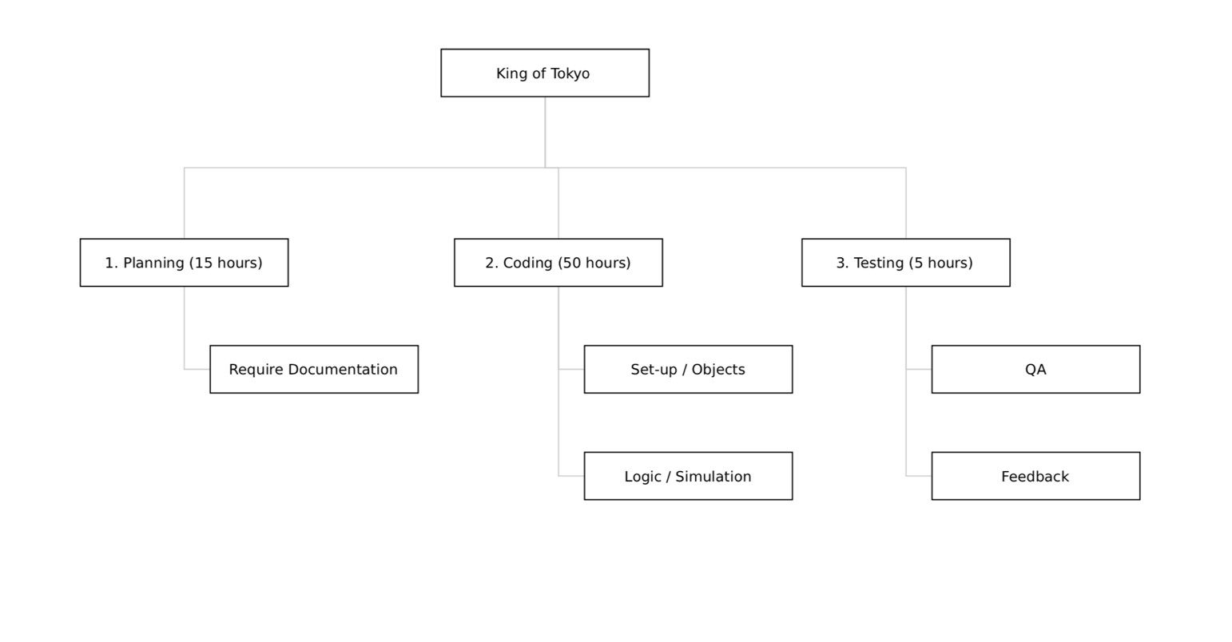

## Schedule and Milestone

**Timeline Chart**

**Link:** [**Gantt Chart**](https://studentcsulb-my.sharepoint.com/:x:/r/personal/aurelio_hueletltorres_student_csulb_edu/_layouts/15/Doc.aspx?sourcedoc=%7B4B932278-1BCB-4F37-91AB-7B87693354EE%7D&file=gantt%20chart-1.xlsx&action=default&mobileredirect=true) **(One Drive)**

**Alternate Link:** [**Gantt Chart**](https://github.com/jondwoo/CECS-343/blob/master/King%20Of%20Tokyo/documents/gantt%20chart-1.xlsx) **(Github)**

## Budget

|  |  |  |  |  |  |  |  |
| --- | --- | --- | --- | --- | --- | --- | --- |
|  | | **Budget for Period in US$** | | | | | |
| **Category** | Start Research-  Start planning | | Start planning-  Start implementation | Start implementation -  Start testing | Start testing -  Release product | Release product-  Close project |
| Human Resources  (internal) |  | |  |  |  |  |
| Human Resources  (external) |  | |  |  |  |  |
| Purchases (COTS) | 35 | |  |  |  |  |
| Equipment |  | |  |  |  |  |
| Premises |  | |  |  |  |  |
| Tools |  | |  |  |  |  |
| Travel costs |  | |  |  |  |  |
| Training |  | |  |  |  |  |
| Review activities |  | |  |  |  |  |
| Other |  | | 5 |  |  |  |
| Total | 35 | | 5 |  |  |  |
| Total cumulated | 35 | | 40 | 40 | 40 | 40 |

## Development Process

## Development Environment

|  |  |  |
| --- | --- | --- |
| **Item** | **Applied for** | **Availability by** |
| **Methods** |  | |
|  |  |  |
|  |  |  |
|  |  |  |
| **Tools** |  | |
| Draw.io | Design | Start planning |
|  |  |  |
|  |  |  |
| **Languages** |  | |
| UML | Design | Start planning |
| Java | GUI | Start implementation |
|  |  |  |
|  |  |  |

## Measurements Program

# Risk Management

Risk will be defined as time-cost to develop the entire software to publish. The time required to finish the project may vary due to unexpected circumstances and therefore extra time must be accounted for. This procedure will take place during the planning stage of the project. The Project Manager and Task Organizer will be responsible for assessing the risk of the development cycle. Risk will be repeatedly assessed during each phase of the project implementation (i.e. after planning, after each deliverable, after each test). The risk will then be communicated directly to the developers of the project and they in-turn will incorporate the information into their project application. The developers will counter with a predicted deadline to match the risk based on the Project Manager/Task Organizer’s projections.

# Communication and Reporting

|  |  |  |  |  |  |
| --- | --- | --- | --- | --- | --- |
| **Type of**  **Communication** | **Method/Tool** | | **Frequency**  **/Schedule** | **Information** | **Participants/**  **Responsibles** |
| Internal Communication |  | | | | |
| Project Meetings | Phone group chat | | 2 days a week | Project status, problems,  Risks, documentation  updates | Major Manager  Project Team  Quality  Assurance |
| Sharing of project data | Github  Trello  Google Documents | | 2 days a week | All the documentation reports  And ideas sharing | Major Manager  Project Team  Quality  Assurance |
| Milestone  Meetings | In person | | 2 days a week | Project status | Major Manager  Project Team  Quality  Assurance |
| Final Project  Meeting | In person | | Release Product | Final Presentation | Major Manager  Project Team  Quality  Assurance |
| **External Communication and Reporting:** | |  | | | |
| Project Documents | Report | | Weekly | Documentation Deadlines | Major Manager  Project Team  Quality  Assurance |

# Delivery Plan

|  |  |
| --- | --- |
| Deliverables: | Date: |
| Understanding the game | 9/30/19 |
| Risk Management Plan | 10/3/19 |
| Project Plan | 10/3/19 |
| Type of code and different properties | 10/5/19 |
| Interface Layout and design | 10/17/19 |
| Usage of game | 10/21/19 |
| Possible procedure to create game | 11/4/19 |
| Game decision | 11/6/19 |
| Code choice and language choice | 11/16/19 |
| Procedure path decision | 11/20/19 |
| Choice of development program | 11/15/19 |
| Creation of sprites | 11/15/19 |
| Image handler | 11/23/19 |
| Sound handler | 11/28/19 |
| Input handler | 11/23/19 |
| Logic handler | 11/23/19 |
| Coding | 12/2/19 |
| Self testing | 12/3/19 |
| Integration testing | 12/3/19 |
| Validation testing | 12/3/19 |
| Performance testing | 12/3/19 |
| Final Product | 12/5/19 |

# Quality Assurance

Ensures quality standards of the product creation and product updates of documents and implementation.

# Security Aspects

This application prioritizes system security as the most important security feature for this project. The developers want to make sure that users cannot hack to the system and change any functionalities of the game as long as stole other users’ information. Accessibility would be the second important thing because the both PC and MAC users should be able to get access to the game.

# Abbreviations and Definitions

|  |  |
| --- | --- |
| **Acronym or Abbreviation** | **Definition** |
| GUI | Graphical User Interface presents an easy-to-use visual display to the user |
| vp | victory point |
| hp | health point |

# References

## Physical board game: How to play King of Tokyo

## Vision Document

## King of Tokyo board game

# Revision

|  |  |  |  |
| --- | --- | --- | --- |
| **Date** | **Version** | **Description** | **Author** |
| 9/27/2019 | <1.0> | Initial draft | Jon Ham, Lam Nguyen, Aurelio Hueletl Torres |
| 12/3 | <1.1> | Updated project manager, steering committee, and gantt chart | Jon Ham, Lam Nguyen |
|  |  |  |  |